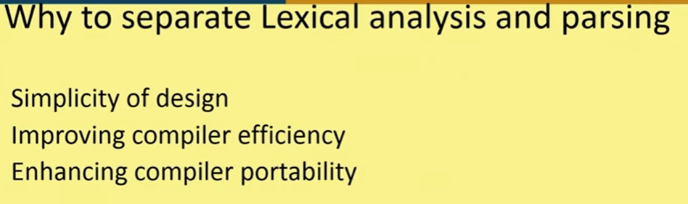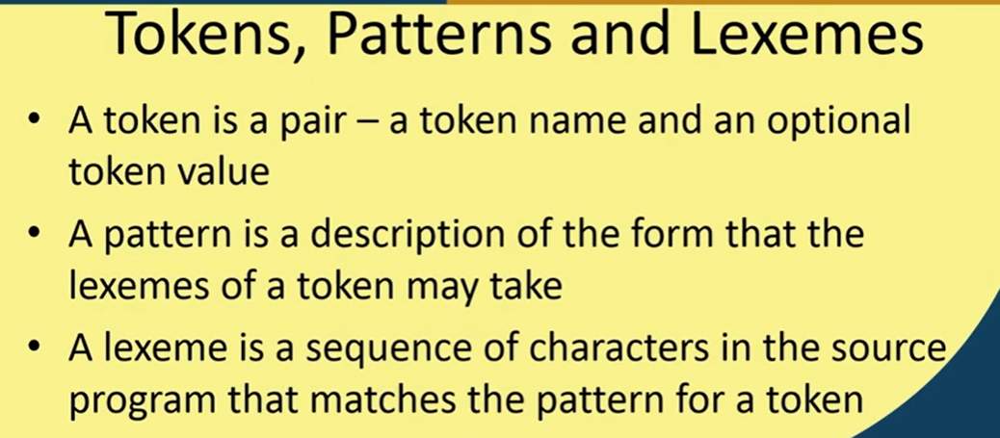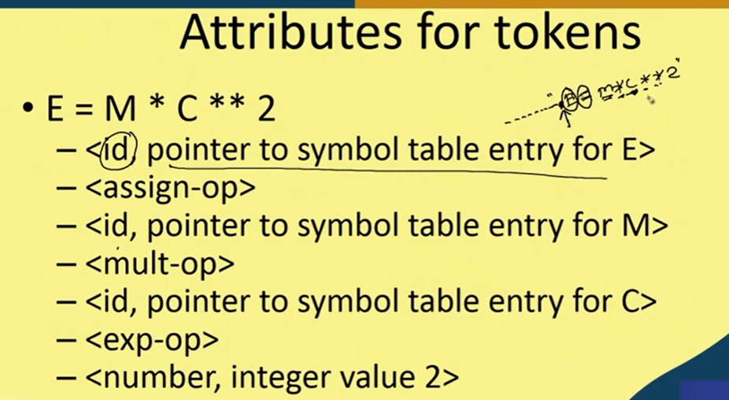

ALSO IDENTIFIES THE ATTRIBUTES

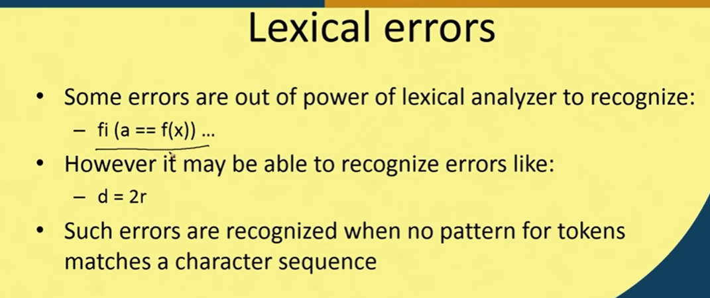

!> doesn’t have much power ( can’t separate errors) => fi 🡪if

!> Since it can identify no symbol can start with int followed by char seq Also no other matching so helpful to find error

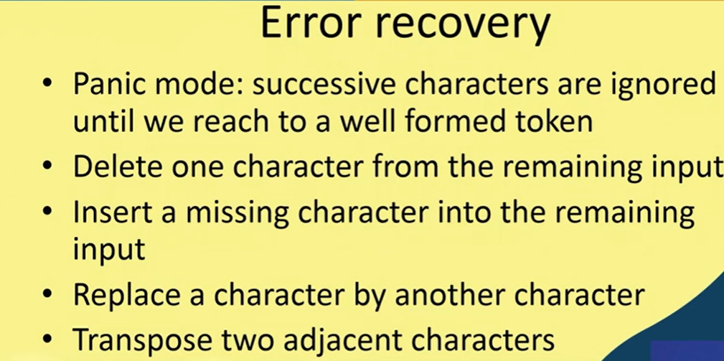

Recovery by : (depends on compiler design)

1. PANIC MODE

EX : C ->{},’;’ ETC

// ignore that and start with fresh token

// it can continue processing all other

1. 2r => 2<operator>r we were expecting
2. So, we delete r or add a missing char



    
    
    

